EMERGENCY MEDICAL SUPPORT (EMS)– MORGUE TRUCK

Dimensions
Road dimensions:
8’6” wide x 32’ long
Approx. 30,000 pounds
Set-up dimensions:
20’ wide x 45’ long
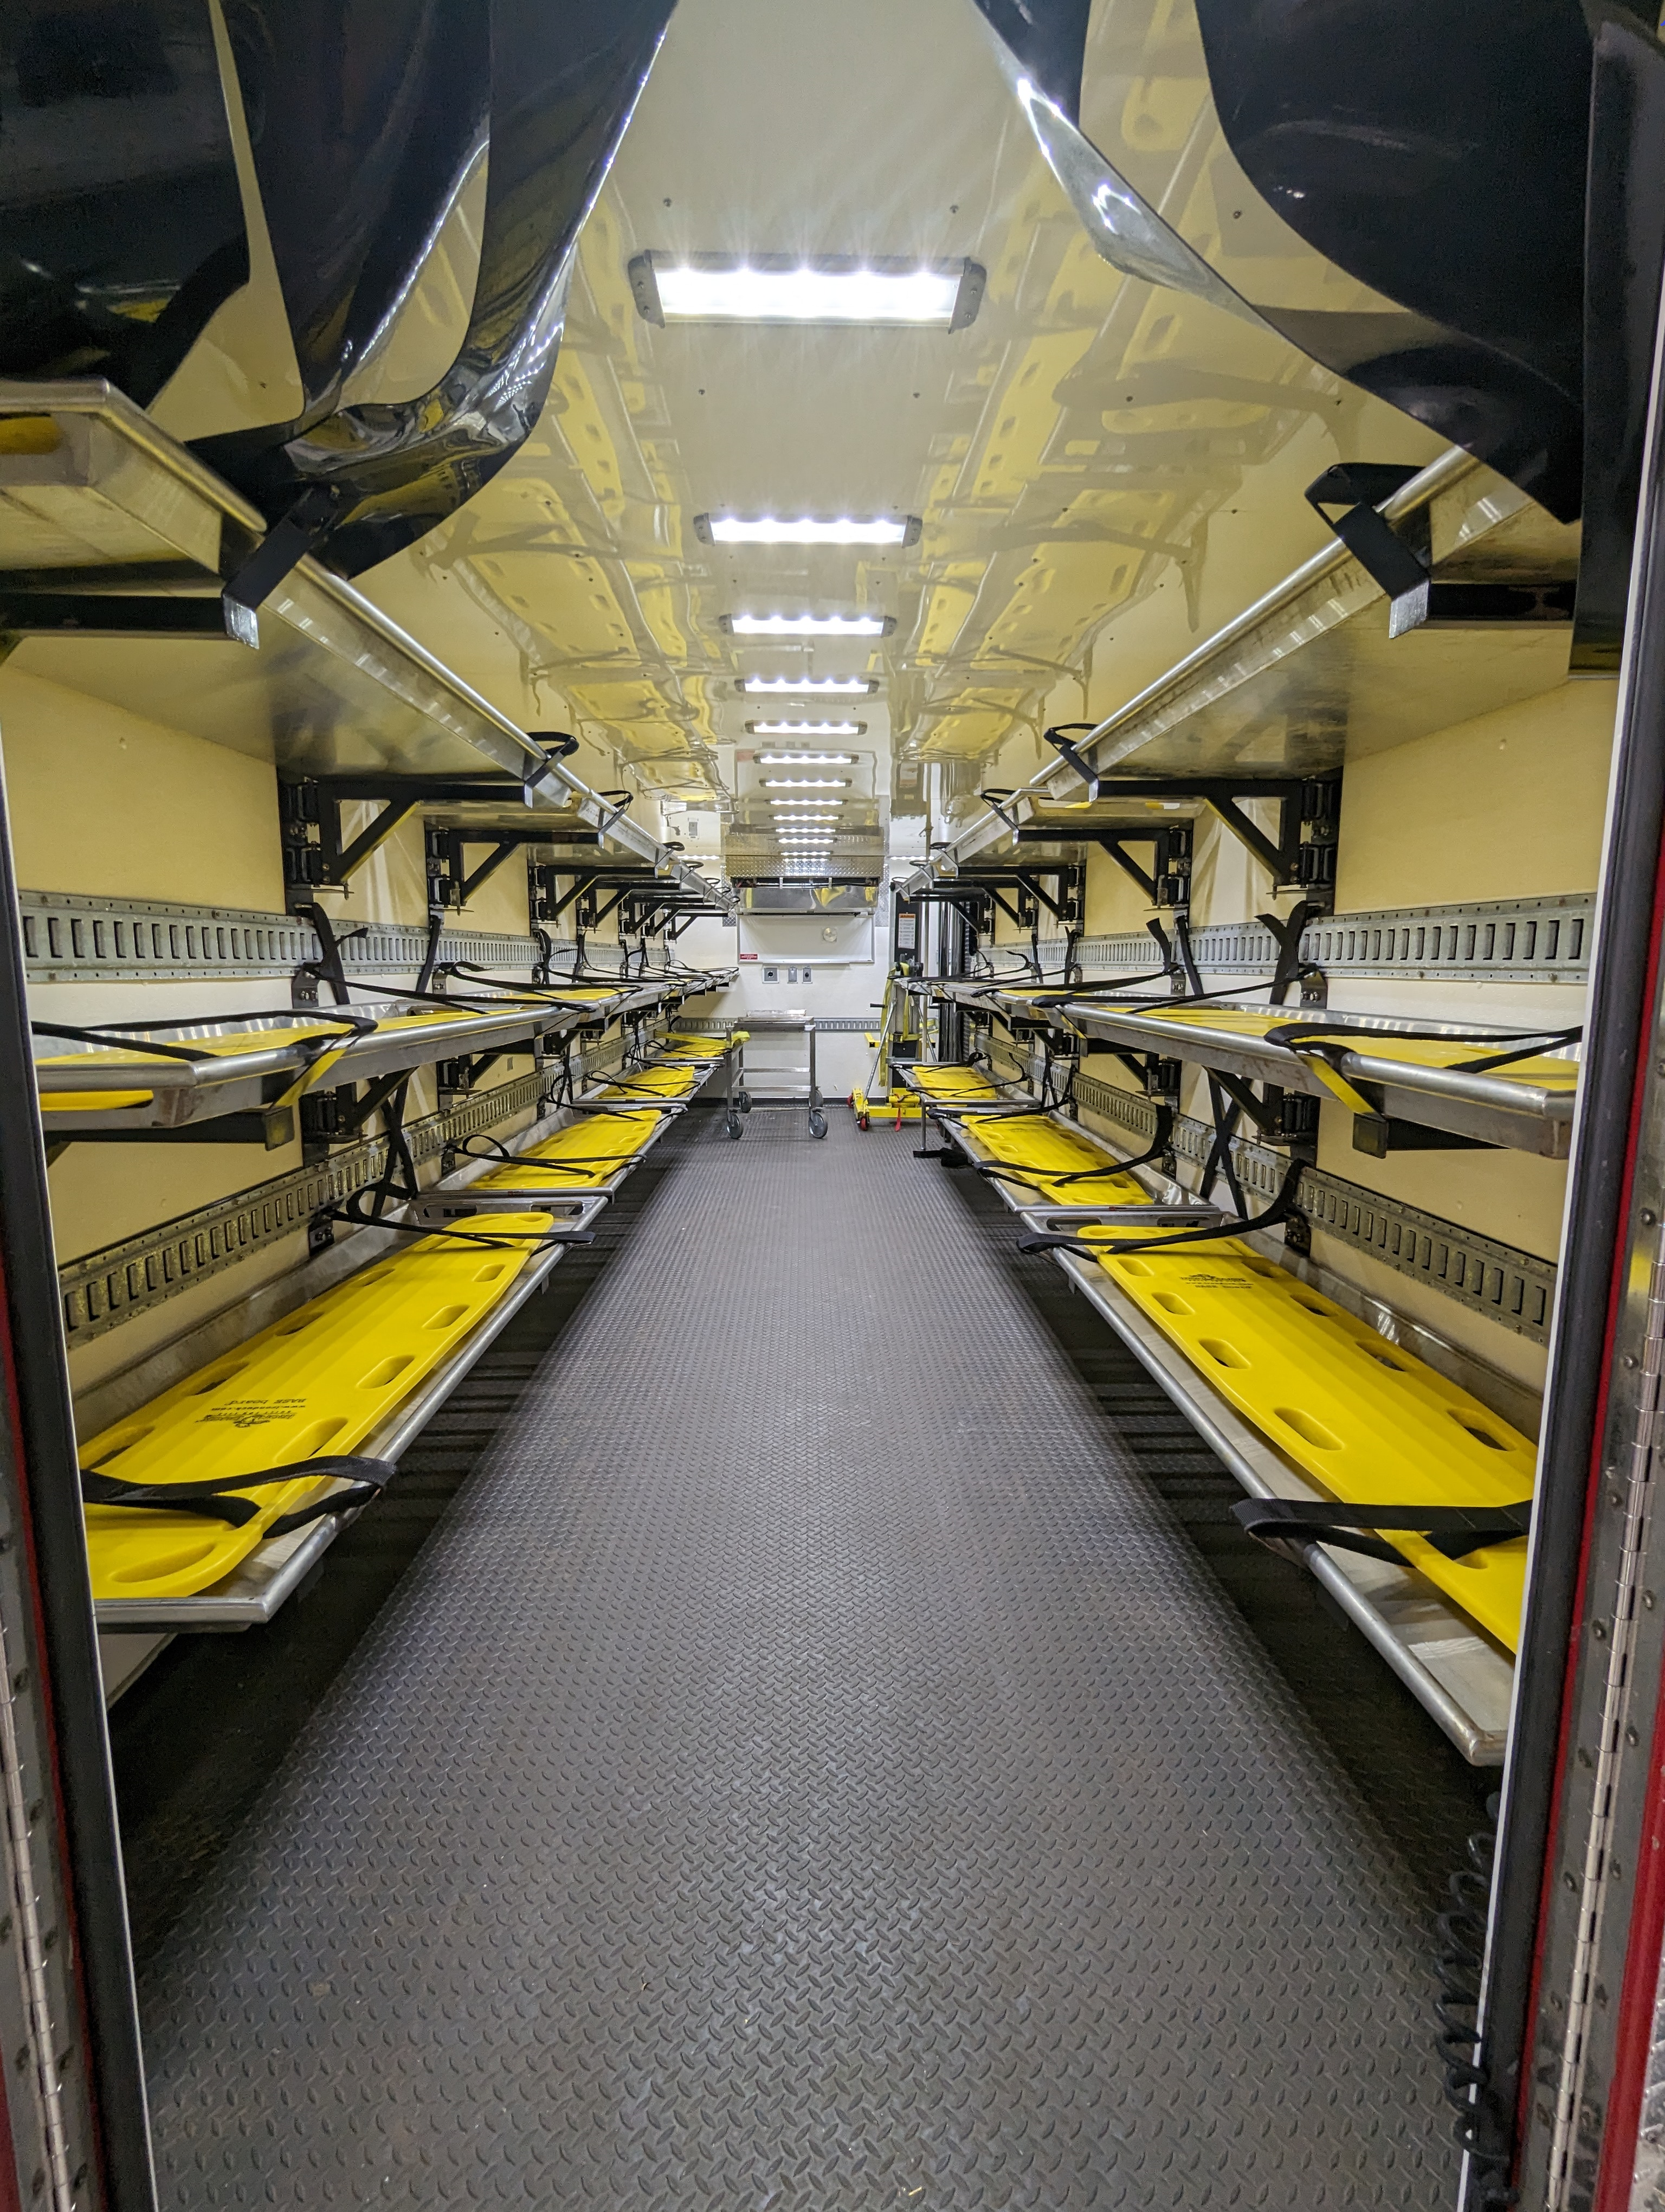
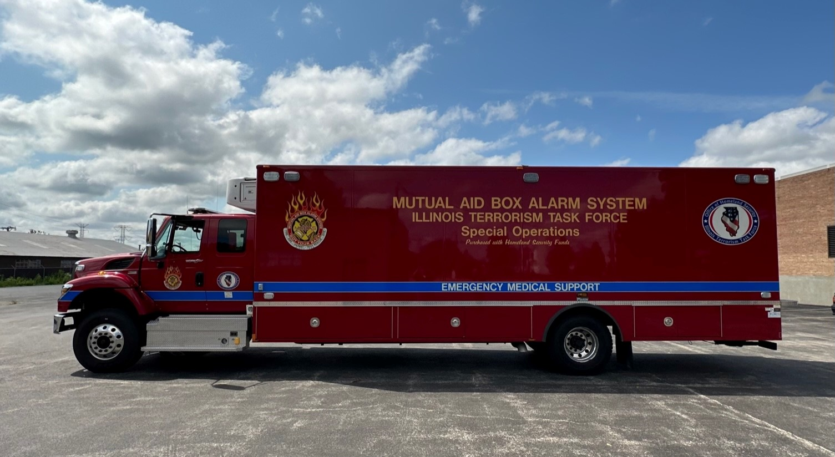
Concept of Operation
The MABAS EMS – Morgue Truck is a completely self-contained mobile morgue vehicle for use to support fatality management and MCI incidents.
Supports:
- ESF-8 Public Health and Medical Services
- Secondary – All ESF’s
Response time is Notification + Travel Time
Number of Units: 1
Location
MABAS MRC, Division 1 (Cook)
Features
- Interior (rear)
- Refrigeration unit
- 28 wall mounted flip-up decedent tray holders
- Decedent trays (28)
- Decedent lift
- Rear lift gate 8’5” wide X 6’4” long
- Patient movement carts
- Human Remains Pouches (100)
- PPE/disinfectant
- MCI/Triage supplies
- Backboards (50)
- Triage tags
- Triage tarps (red, yellow, green, black)
- VHF & (1) STARCOM 21 mobile radio mounted in the cab
NIMS Typing: n/a
FEMA Cost Code: 8797
Equipment Rate: $54.63 per hour
Specifications
Road dimensions:
8’5” wide x 29’ long
Height = 11’10”
Set-up dimensions:
14’ wide x 60’ long
GVWR: 40,000 lbs
INVENTORY MASTER LIST
DESCRIPTION | QTY. | LOCATION
Biohazard Bag, 30.5”x 41" | 60 | Left Rear Exterior Compartment
Blanket, Economy | 50 | Left Rear Exterior Compartment
Numbered Zip Ties (Red) | 200 | Inside Cab
Human Remains Pouches | 100 | Right Rear Exterior Compartment
Decedent Trays | 35 | Inside Rear (28) & Left Front Exterior Compartment (7)
Face Shield | 100 | Left Rear Exterior Compartment
Isolation Gowns | 120 | Left Rear Exterior Compartment
VioNex Antiseptic Wipes | 1 case | Left Rear Exterior Compartment
N95 Masks | 240 | Left Rear Exterior Compartment
Glove, Freeform SE, Large | 2000 | Left Rear Exterior Compartment
Metal Clipboards | 2 | Inside Cab
Legal Paper | 1 ream | Inside Cab
Dry-Erase Markers | 1 box | Inside Cab
Pens, Pencils, Highlighters (Yellow) | 1 box ea | Inside Cab
Markers (Black) | 4 | Inside Cab
Triage Board | 1 | Inside Cab
Wheel Chocks | 1 set | Inside Cab
Vest w/Window Pockets (Blue, Green, Lime Green, Orange, Red, White, Yellow) | 2 each | Left Front Exterior Compartment
Backboard, Straps (Orange) | 90 | Left Rear Exterior Compartment
Backboard, Base (Yellow) | 50 | Inside Rear (28), Left Middle Exterior and Right Front Exterior Compartments
Garbage Cans, 40 gal | 4 | Inside Rear
Garbage Can Lids | 4 | Left Front Exterior Compartment
Garbage Bags, 42 gal | 40 | Left Rear Exterior Compartment
Hand Lights | 4 | Inside Cab
Patient Movement Carts | 4 | Inside Rear
Tarp, Triage 10’ x 12’ (Green, Yellow, Red, Black) | 2 each | Left Front and Left Middle Exterior Compartments
Flags, Triage (Green, Yellow, Red, Black) | 100 each | Left Rear Exterior Compartment
Triage Tags | 100 | Left Rear Exterior Compartment

