mutual aid box alarm system
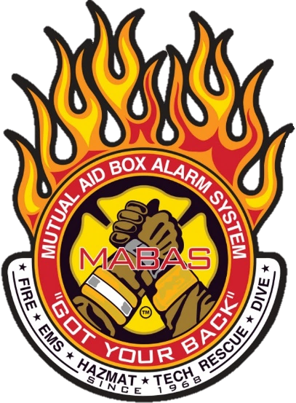
MOBILE VENTILATION UNIT (MVU)
Concept of Operation
The MABAS Mobile Ventilation Units (MVU) can be used to control the movement of air, heat and gases inside any large enclosed structure, rail or road tunnels and provide a misting system for cooling.
Supports: All ESF’s
Response time is Notification + Travel Time

NIMS Typing: n/a
FEMA Cost Code: 8805 (cost $264 per day)
Equipment Rate: $21.94 per hour

Specifications
Road dimensions:
9’ wide x 24’ 2” long x 11’ 5” height
GVWR: 14,962 LB

*Driver’s License required – Class C

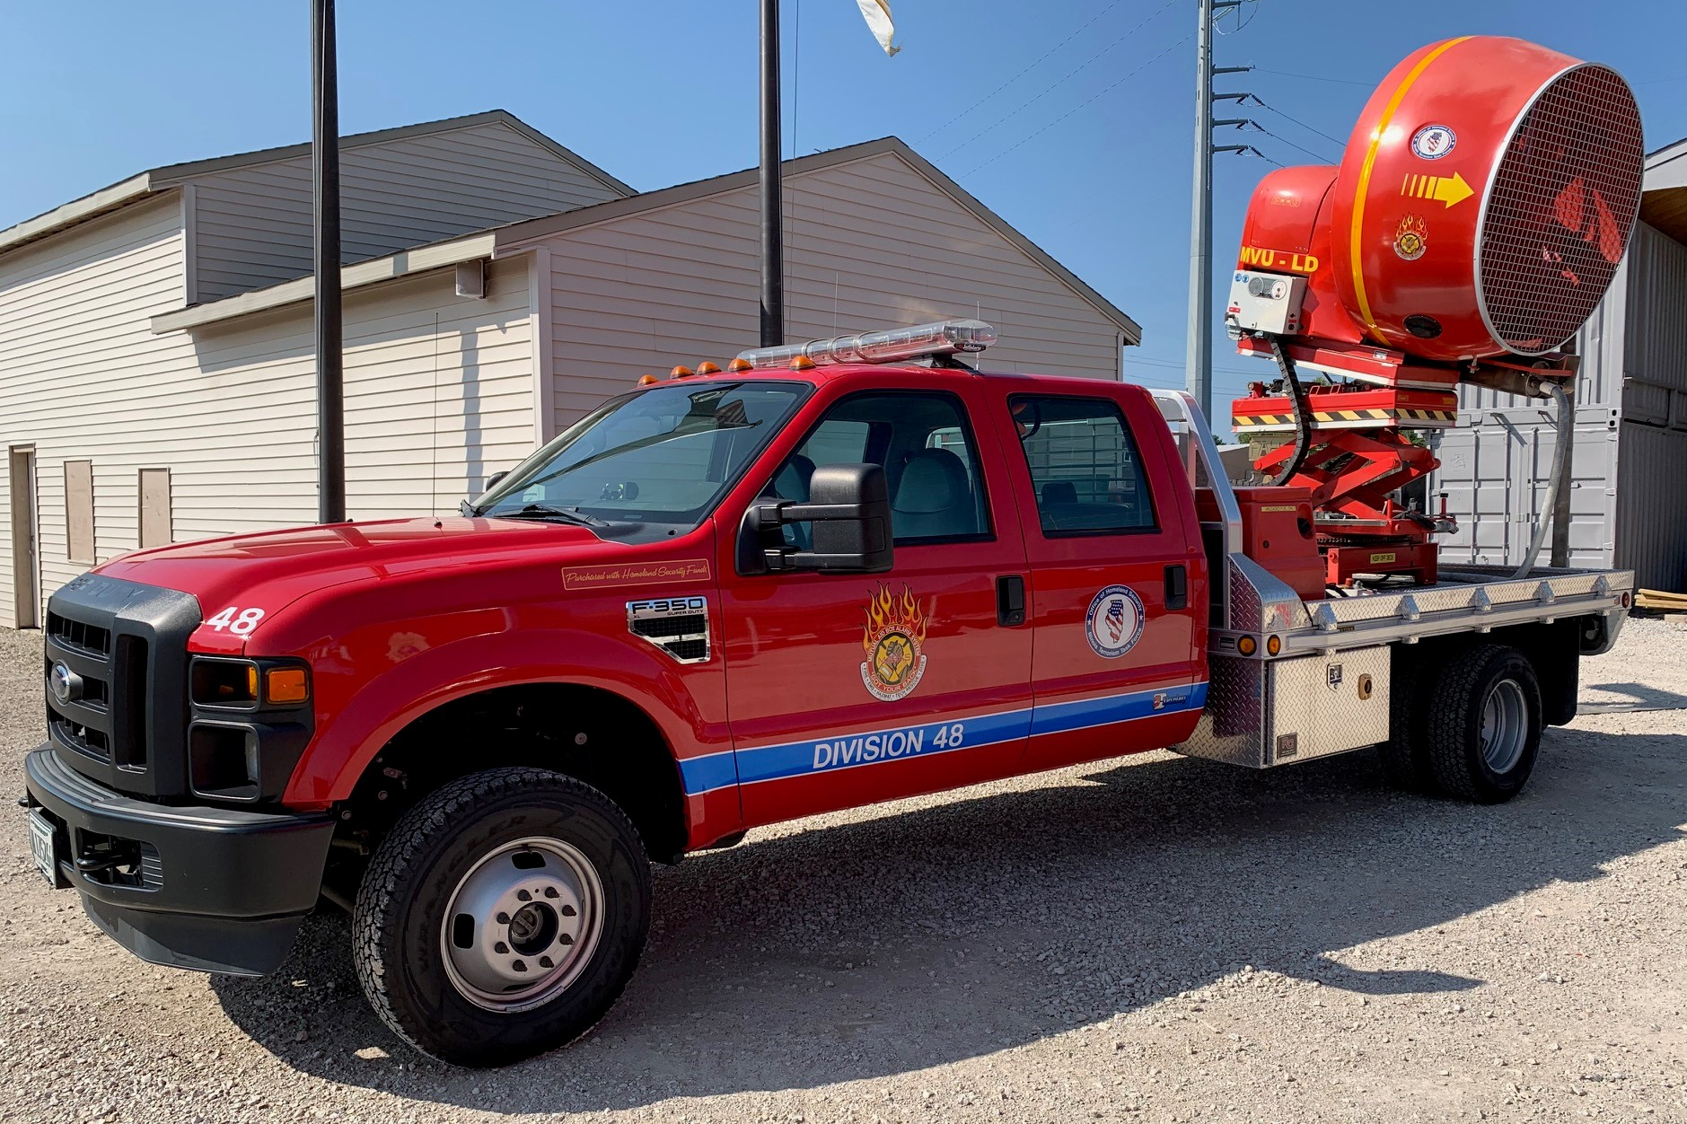
Features
- Ventilation Fan Capability
- Maximum fan operational height: 15’ 7’’
- Output: up to 130,000 CFM
- Fan rotation: 360*
- Tilting gear: +/- 30*
- Water misting system (water supply is needed)
- Run time ~ 2.5 hours
- Fuel: Premium gasoline
- VHF mobile radio mounted in the cab

Number of Units = 8
Locations
- Division 1 (Cook) Division 28 (Champaign)
- Division 8 (Winnebago) Division 32 (St. Clair)
- Division 10 (Cook) Division 45 (Williamson)
- Division 27 (Will) Division 48 (Sangamon)

