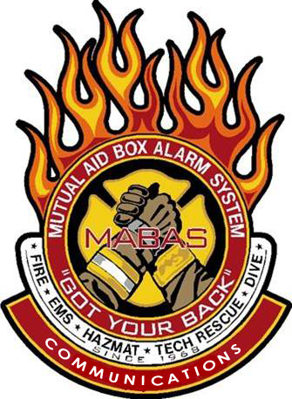

This seminar will take place at the

**Bloomington Fire Station 2**

**1911 E Hamilton Road Bloomington IL, 61704**

**To register, email the *attendee name*, *agency* and *MABAS Division#,* and their *individual email address* to *tcd@redcenter.org***

Thursday, October 20, 2022

#### Time: 08:30-4:30 Lunch will be Provide

#### Overtime/Backfill reimbursement is available! Class limited to 40 participants! Register early!

##### ***HIGHLIGHTS***

* MABAS overview
* Box Cards
* Communications Tool Box
* From Rural to Large Responses and Deployments
* Box Alarm simulator
* An outside Asset display and more….

Hello everyone!

The MABAS Communications training group is returning to your area to offer a wide variety of

MABAS related topics, to assist you in preparing for daily to worst-case responses.

***ALL First Responders*** are encouraged to attend….

Email tcd@redcenter.org to register!

We hope to see you there!

Attention ***ALL***

First Responders!

You are invited to attend!

***A MABAS***

***Regional Training Seminar***