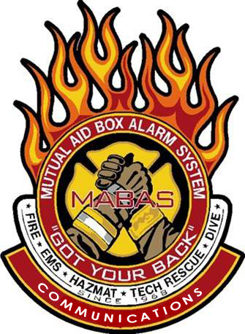

This seminar will take place at the

**Fermilab IARC Building**

**\*\*Note** the building has no actual address. Attendee’s should enter off Pine Street gate off Kirk Road.**

**To register, email the *attendee’s name*, *agency* and *MABAS Division#,* and their *individual email address* to** [***tcd@Mabas-il.org***](mailto:tcd@Mabas-il.org)

December 5th, 2023

#### Time: 08:30-4:30 Lunch will be Provide

#### Class limited to 40 participants! Backfill / OT reimbursement available!

##### ***HIGHLIGHTS***

* MABAS overview
* Box Cards
* From Rural to Large Responses and Deployments
* Box Alarm simulator
* An outside Asset display and more….

Hello everyone!

The MABAS Communications training group is returning to your area to offer a wide variety of

MABAS related topics, to assist you in preparing for daily to worst-case responses.

***ALL First Responders*** are encouraged to attend….

***Email tcd@mabas-il.org to register***!

We hope to see you there!

Attention ***ALL***

First Responders!

You are invited to attend!

***\*\*No Cost\*\****

***MABAS***

***Regional Training Seminar***