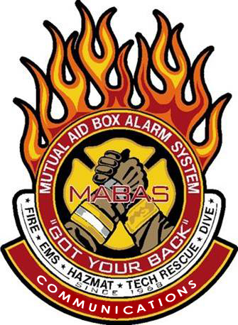
This seminar will take place at the
Illinois Fire Service Institute – Paratech Room
11 Gerty Drive, Champaign, IL 61820

To register, email the attendee name, agency and MABAS Division#, and their individual email address to tcd@redcenter.org

Time: 08:30-4:30 Lunch will be Provided

Class limited to 40 participants! Register early!

The MABAS Communications Committee will be holding a Regional Training Seminar for the Champaign area!
We will cover a wide variety of
MABAS and Communications related topics!

ALL First Responders are encouraged to attend to learn the critical role they play in the MABAS system!

To Register: Send Attendees name, direct email and Division affiliation to tcd@mabas-il.org

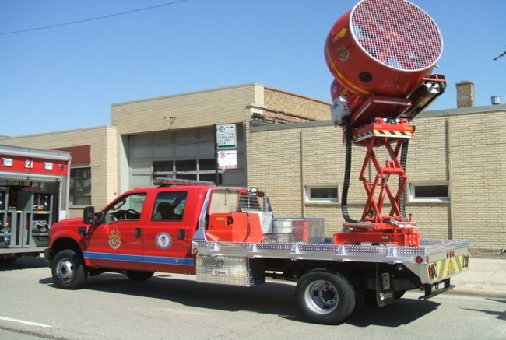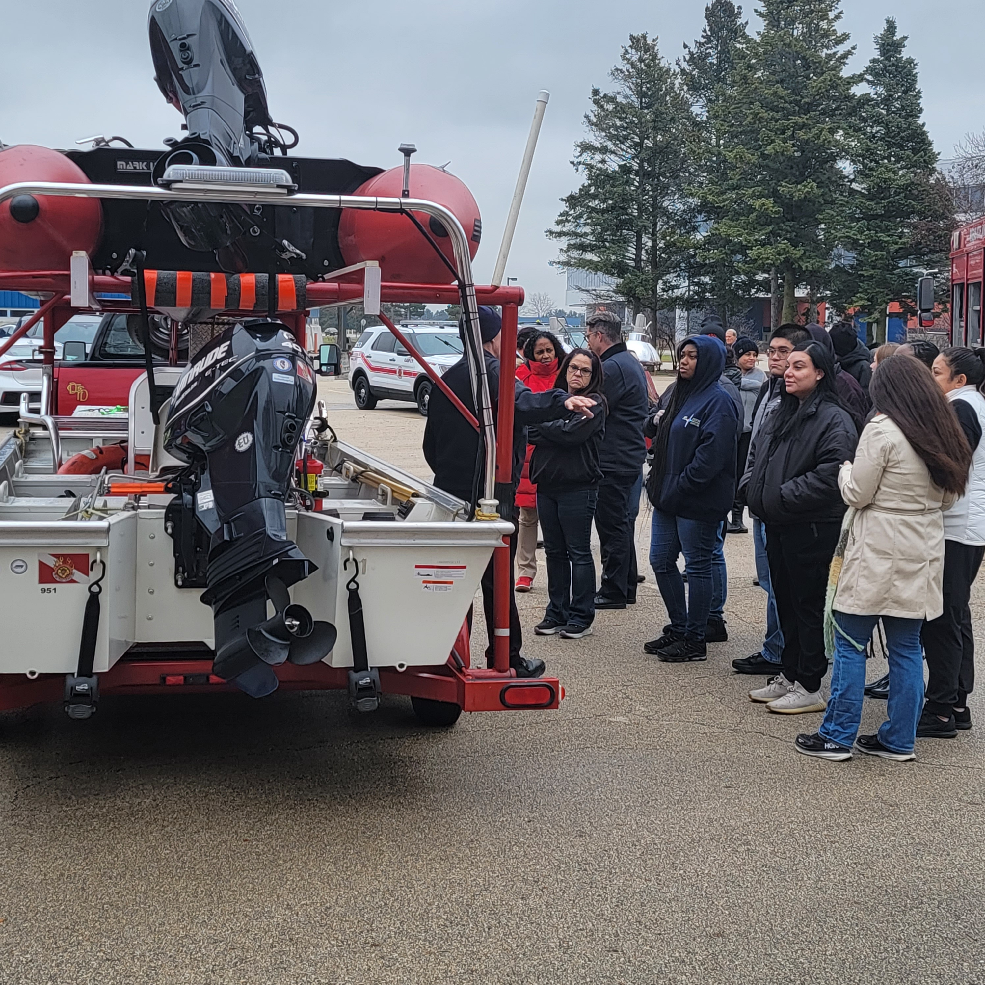

Attention ALL First Responders!

You are invited to attend a FREE MABAS Training Seminar!

Thursday September 5th, 2024

HIGHLIGHTS
- MABAS overview
- History of MABAS
- Box Cards
- Deployments
- Box Alarm simulator
- An outside Resource display and more….

