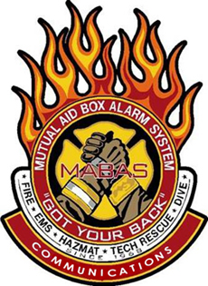

MABAS Communications Exercise
Stephenson County, Illinois

August 27th, 2024 8:30-16:30

08:30-09:30 | Introduction  Course Overview  Introductions and MABAS 101
09:30-11:00 | M.A.B.A.S Basics  History of M.A.B.A.S- How we got here & why its working!  The Box Cards: What are they, How we use them, & Why you need them!
11:00-13:00 | Dispatchers Tool Box (Working Lunch)  An open presentation on real world incidents, and how they can help you when the ‘big one’ happens!
13:00-14:00 | M.A.B.A.S Special Teams and Assets  Local / Regional /State assets; what are they, where are they, when can & would they be needed and who do you call….. All covered in this interactive presentation!
14:00-14:30 | From Regional issues to Statewide Deployments  A review of the issues incurred locally all the way to the Statewide Mutual Aid Plan, The M.A.B.A.S Preparedness Workbook, Esponder, the roll of the MABAS dispatchers and the importance of proper documentation
14:30-15:30 | Lessons Learned  A review of some area incidents and what we can learn from being more involved locally, and within your division!

15:30-16:30 Simulator drills
“Live” radio drills, for all attendees to practice dispatching a Box Alarm!

