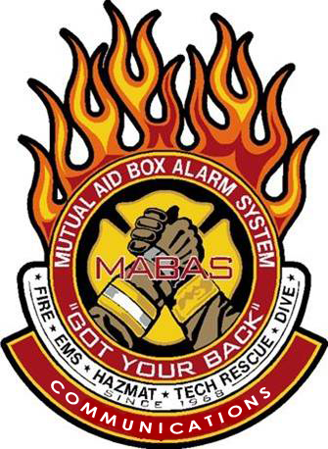

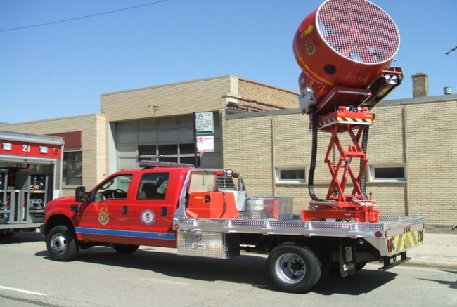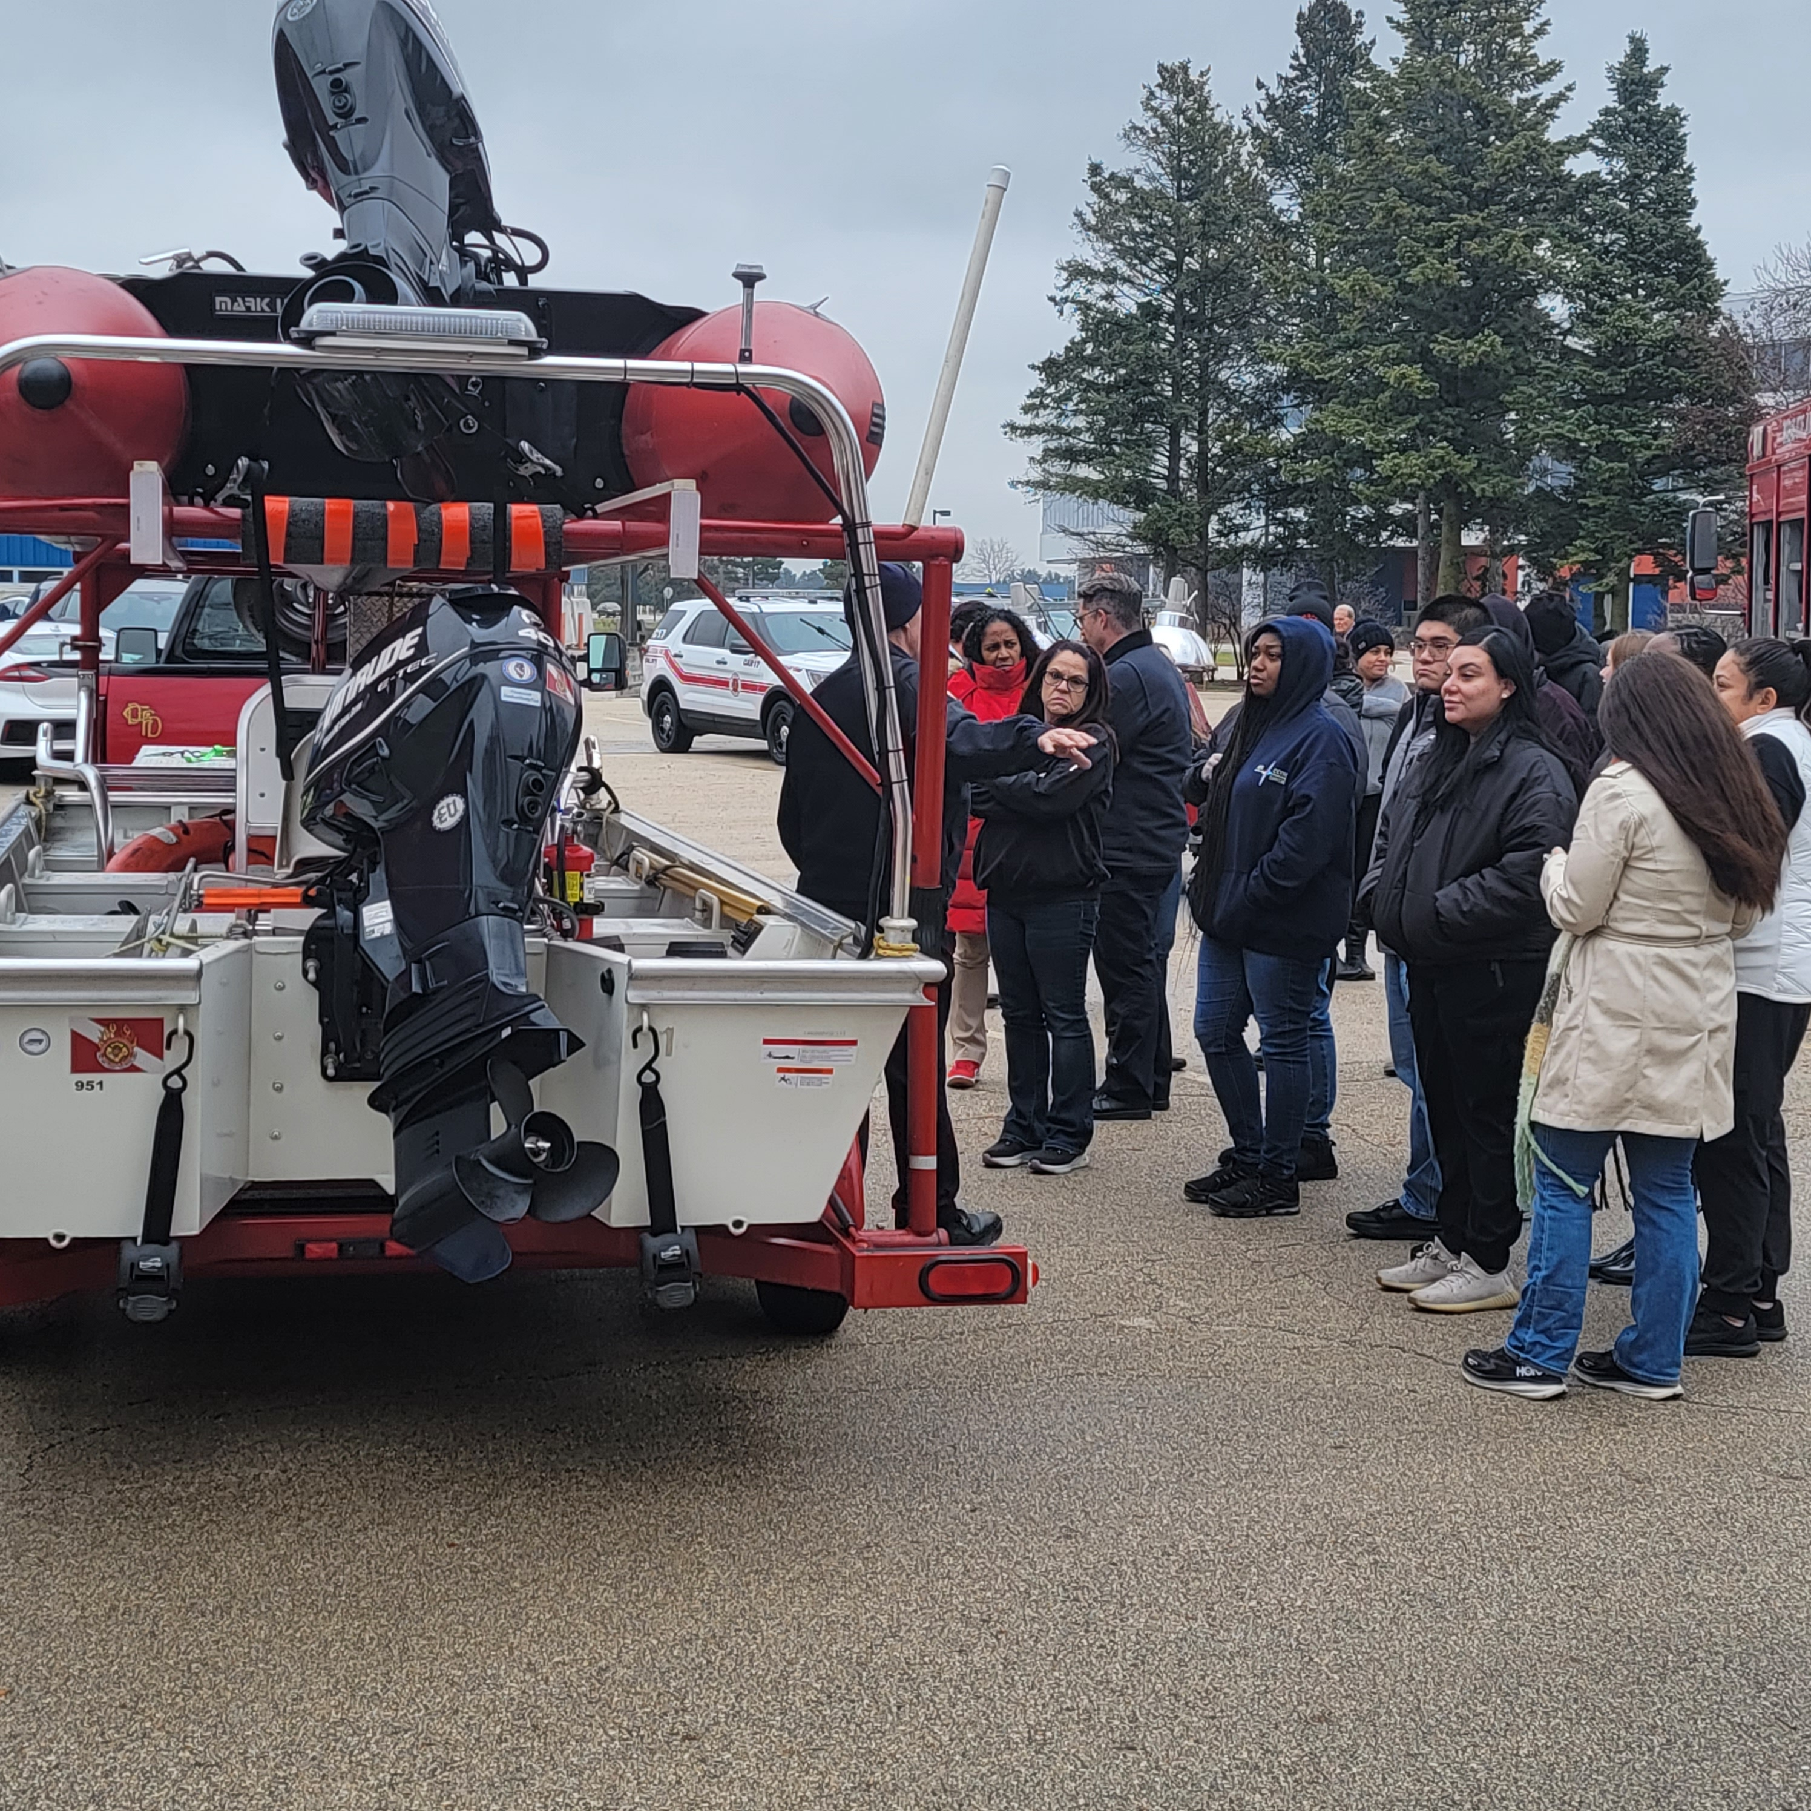

Attention ALL First Responders!

You are invited to attend a FREE MABAS Training Seminar!

This seminar will take place at the
Wescom Dispatch Center
24600 Presidential Avenue, Plainfield, IL 60544

To register, email the attendee name, agency and MABAS Division#, and their individual email address to tcd@redcenter.org

Time: 08:30-4:30 Lunch will be Provided

Class limited to 40 participants! Register early! OT/Backfill reimbursement is available!

WesCom Dispatch has graciously agreed to host a Regional Training Seminar at their amazing facility!
We will cover a wide variety of
MABAS and Communications related topics!

ALL First Responders are encouraged to attend to learn the critical role they play in the MABAS system!

To Register: Send Attendees name, direct email and Division affiliation to tcd@mabas-il.org
Thursday November 7th, 2024

HIGHLIGHTS
- MABAS overview
- History of MABAS
- Box Cards
- Deployments
- Box Alarm simulator
- An outside Resource display and more….

