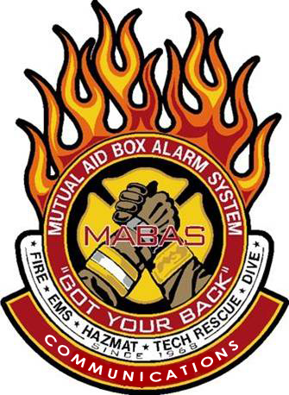

Class limited to 40 participants! Lunch provided, courtesy of:


This seminar will take place at the
Franklin County OEMC
403 East Main Street
Benton, IL. 62812

To register, email the attendee name, agency and MABAS Division#, and their individual email address to tcd@redcenter.org

Saturday May 23, 2026 08:30-16:30
The MABAS Communications Committee will be holding a Regional Training Seminar for the Franklin County area!
We will cover a wide variety of
MABAS and Communications related topics!

ALL First Responders are encouraged to attend to learn the critical role they play in MABAS!
To Register: Send Attendees name, direct email and Division affiliation to tcd@mabas-il.org

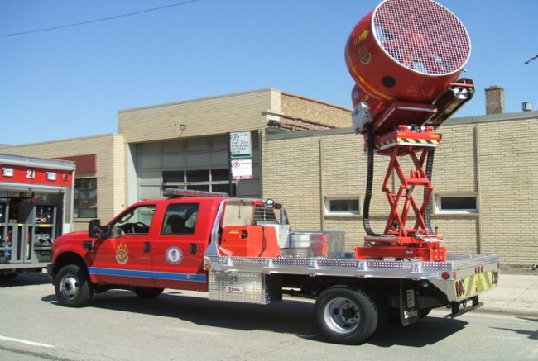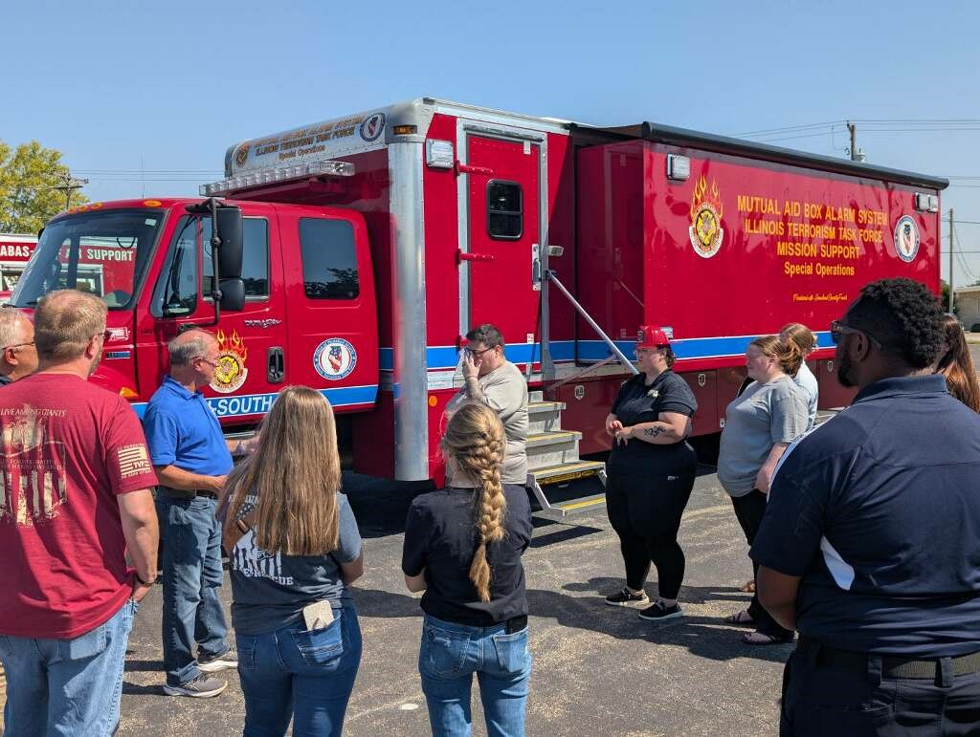

Attention ALL First Responders!

You are invited to attend a FREE MABAS Training Seminar!

HIGHLIGHTS
- MABAS overview
- History of MABAS
- Box Cards
- Deployments
- Box Alarm simulator
- An outside Resource display and more….

